Portfolio Optimization and Risk Analysis using Python
Objective
The objective of this project is to construct an optimal portfolio using Modern Portfolio Theory and evaluate its performance using financial models such as CAPM, Monte Carlo simulation, and risk metrics.
Data Collection
Historical stock price data was collected using Yahoo Finance for:
- Reliance Industries
- TCS
- Infosys
- HDFC Bank
NIFTY index was used as the market benchmark.
Exploratory Data Analysis
Stock price trends show that all stocks exhibit long-term growth, with TCS showing the highest price levels and HDFC Bank showing relatively stable movement.
The correlation matrix reveals moderate correlations (0.3–0.7), indicating diversification benefits.
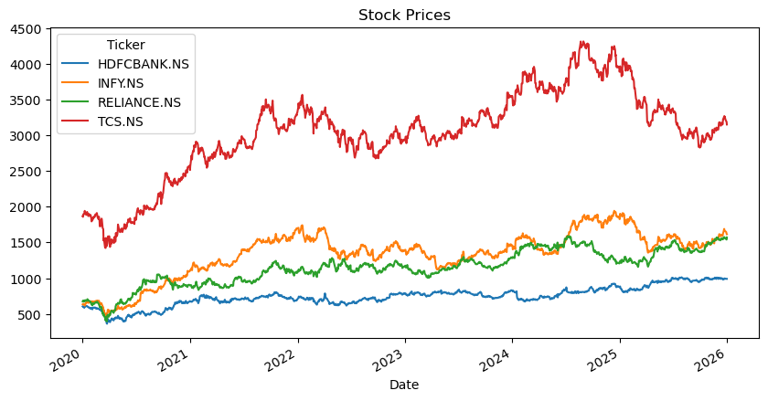
Correlation Analysis
The correlation heatmap illustrates the relationship between the selected stocks.
The correlations range between 0.3 and 0.7, indicating moderate relationships among the stocks. Notably, INFY and TCS show higher correlation due to being in the same sector, while HDFC Bank has relatively lower correlation with IT stocks.
This suggests that diversification benefits can be achieved by combining these assets, as they are not perfectly correlated.
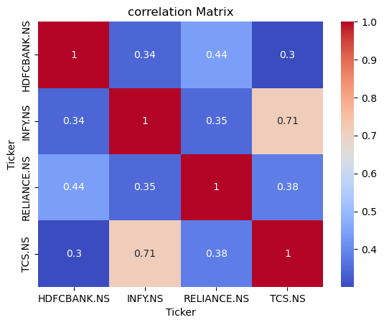
Portfolio Optimization (MPT)
Using Monte Carlo simulation (5000 portfolios), an efficient frontier was constructed (page 5).
🔹 Optimal Portfolio:
- Risk: 0.0139
- Return: 0.000731
- Sharpe Ratio: 0.0526
Sharpe = (Return − Risk-Free Rate) / Risk
This portfolio provides the best trade-off between risk and return.
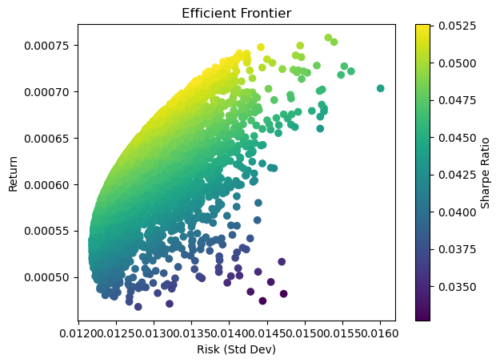
Backtesting
The optimized portfolio was backtested against the NIFTY benchmark.
Insights:
- Portfolio closely follows market trend
- Slight outperformance in certain periods
- Performs consistently across different market conditions
Indicates a robust and diversified strategy
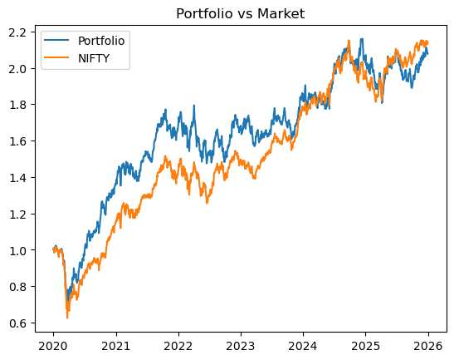
CAPM Analysis
Expected Return = rf + Beta × (Market Return − rf)
- Beta: 1.115
- Expected Return: 0.000619
Interpretation:
- Beta > 1 → portfolio is more volatile than the market
- Expected return justifies higher risk
Monte Carlo Simulation
Monte Carlo simulation was used to model future price paths.
Insights:
- Wide distribution of outcomes
- Highlights uncertainty in future returns
- Helps assess best/worst-case scenarios
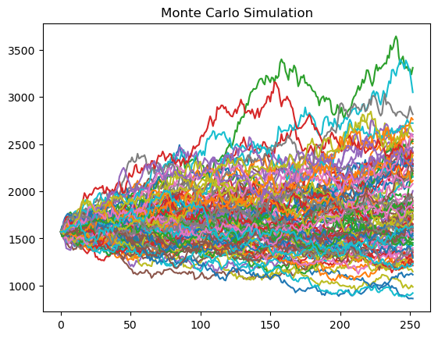
Risk Analysis
- Value at Risk (95%): -1.71%
- Maximum Drawdown: -34.82%
Interpretation:
- Moderate downside risk
- Significant drawdowns possible during market crashes
Key Financial Concepts Used
- Modern Portfolio Theory (MPT)
- Efficient Frontier
- CAPM
- Monte Carlo Simulation
- Value at Risk (VaR)
- Maximum Drawdown

Conclusion
This project demonstrates how quantitative techniques can be used to construct an optimal portfolio while balancing risk and return. The results highlight that diversification improves performance, but market risk remains significant. The strategy is suitable for investors with moderate to high risk tolerance.
Tools Used
Python, Pandas, NumPy, Matplotlib, Seaborn, yfinance

